TABLE OF CONTENTS
SUBJECT PAGE NO.

Details
- Project Name . . . . . . . . . . . . . . 2
- Project Description . . . . . . . . . . . 2
- Limitations . . . . . . . . . . . . . . . . 2
- Interfaces . . . . . . . . . . . . . . . . . 3
- Functional Capabilities . . . . . . . . . 3-4
- Screen Flow . . . . . . . . . . . . . . . . 4-15
- Data Flow Diagram . . . . . . . . . . . 16
- Performance Levels . . . . . . . . . . . 17
- Security Features . . . . . . . . . . . 17
- User Roles . . . . . . . . . . . . . . . 17
- Appendices
Appendix A: Project Risk Inventory
Appendix B: Project Work Plan
Appendix C: Project Estimating Worksheet
- Sign-off

Definition of Terms (This section refers to words and terms used that need to be defined to facilitate understanding and ensure proper interpretation of the document.)

BDOLF – BDO Leasing and Finance
AAF – Ambit Asset and Finance
NTC – Net-To-Close
ICBS – International Comprehensive Banking System
FaMS – Factors Management System

Details

- Project Name
  - NTC Consolidator.

- Project Description
  - For Accounting MIS
    - Consolidate data coming from ICBS, AAF and FaMS Application and save to Consolidator Database. Generate Reports and Exception Reports in Excel format.
- Limitations
  - Denormalized Database design.
  - No Direct Access from ICBS Application instead use ICBS download text file.

- Interfaces
  - ICBS – Extract data from text file created by ICBS Application.
  - AAF – Pull data from AAF database.
  - FaMS – Pull data from FaMS database.

- Functional Capabilities
  - For Accounting MIS
    - Upload data from ICBS text file.
      - Fields
        - PN Number
        - Customer Name
        - Officer (AO Code)
        - Product Description
        - Status Code
        - Book Date
        - Maturity Date
        - Amount Financed
        - O/S Bal. (Orig.)
        - O/S Bal. (Orig.)
        - AIR (Orig.)
        - New Interest Rate
        - Current Interest Rate
        - Term in Months
        - Rate Type
        - Non-Accrual Date
        - Industry Classification
        - Class Description
        - Class Description
        - Collateral Code
        - Size of Firm
        - Branch No.
        - Nationality
        - Next Rate Review Date
        - Tax ID No.
        - Loan Purpose Code
        - Maturity Type Code
        - Bank Relationship
        - Syndicated Loan Ind.
        - Customer Typeand Customer Type Desc.
        - Dosri Tag
        - Collateral Code
        - Collateral Value
        - Line Amount
        - Last Principal Payment
        - LPP Date
        - Last Interest Payment
        - LIP Date
      - Parameters
        - If Currency = “1” Convert the into pesos the following field : Amount Financed, O/S Bal. (Orig.), O/S Bal. (Orig.), AIR (Orig.), Collateral Value, Line Amount, Last Principal Payment and Last Interest Payment.
      - Output File
        - Push/Append to NTC database.
  - For Accounting MIS
    - Pull data directly from AAF Database.
      - Fields
        - Account Number
        - Client Name
        - AO
        - Prod Type
        - Status
        - Value Date
        - First Due Date
        - Maturity Date
        - Total Loan
        - OB
        - Monthly OB
        - UDI Balance
        - Orig ERV
        - PVRV
        - Orig GD
        - PVGD
        - Effective Rate
        - EYA After Reprice
        - Term
        - Remaining Term
        - Orig. Amort.
        - Amort. Per Pay Sched.
        - Reprice Date
        - Rate Type
        - Reprice Amort.
        - Past Due Date & ITL Date
        - Industry Code
        - Industry Detail
        - Industry Detail
        - Collateral
        - Asset Size
        - GL Code
        - GL Desc
        - Cost Center
        - Branch Per Cost Center
        - Orig. Branch
        - Nationality
        - Next Review Date
        - Tax ID
        - Borrower Type
        - REL Code
        - REE Code
        - Free Addtl. Info
        - Act. Ref.
        - RPT
        - Asset Cost
        - Lease Type
        - ICBS Collateral Code
        - Asset Value
        - Approved Amount
        - CP Number
        - Last Principal Pay
        - Principal Pay Date
        - Last Interest Pay
        - Last Interest Pay Date
      - Parameters
        - If Currency = “USD” Convert into pesos the following field: Total Loan, OB, Monthly OB, UDI Balance, Orig. ERV, PVRV, Orig. GD, PVGD, Orig. Amort., Amort. Per pay Sched., Reprice Amort., Asset Cost, Asset Value, Approved Amount, Last Principal Pay and Last Interest Pay.
      - Output File
        - Push/Append to NTC database.
  - For Accounting MIS
    - Pull data directly from FaMS Database.
      - Fields
        - Client Code
        - Client Name
        - Account Officer
        - Status
        - Base Lending Rate Date From
        - Base Lending Rate Date To
        - Investment Limit
        - Receivables
        - Receivables
        - Clients Equity of Unpaid Invoices
        - Discount Charge - Accrual
        - Current DC %
        - Current DC %
        - Credit Term
        - Industry Code
        - Industry Details / Description
        - Industry Details / Description
        - Size of Firm / Asset Size
        - Review Date
      - Parameters
        - Skip if Receivables = 0
        - Skip if Status = “Past Due”
      - Output File
        - Push/Append to NTC database.
  - For Accounting MIS
    - Generate Consolidated NTC Report.
      - Fields
        - SYSTEM
        - Account Number
        - Client Name
        - AO
        - Facility Code
        - Status (PER SYSTEM)
        - Value Date
        - First Due Date
        - Maturity Date
        - Total Loan
        - OB
        - Monthly OB
        - UDI Balance
        - Client’s Equity
        - Accrued Interest Receivable
        - Orig ERV
        - PVRV
        - Orig GD
        - PVGD
        - Total Loan Portfolio
        - NTC
        - Original Rate
        - Current Rate
        - Term in months
        - Remaining Term in months
        - Original Amortization (AAF)
        - Payment Schedule Amortization (AAF)
        - Repriced Date
        - (AAF/ICBS) Rate Type
        - Repriced Amortization
        - Past Due Date/ITL Date Extracted Per AAF/ICBS
        - Per FaMS/AAF/ICBS Industry Code
        - Industry Header
        - Industry Detail
        - Collateral
        - Per FaMS/AAF/ICBS Asset Size
        - Per FaMS/AAF/ICBS Asset Size (In words)
        - ICBS GL Code
        - ICBS GL Name
        - Cost Center
        - Branch Name of Cost Center (Per System)
        - Status (Per GL)
        - Originating Branch (Booked)
        - Nationality (per ICBS)
        - Next Rate Review Date (Extracted per FaMS/AAF/ICBS)
        - Tax ID
        - Loan Purpose Code
        - Maturity Type Code
        - Bank Relationship
        - Syndicated Loan Ind.
        - Customer Type Description
        - REL Code
        - REE Code
        - REE Addtl. Info.
        - Acct. Ref.
        - RPT
        - Asset Cost
        - Lease Type
        - Provisioning
        - Matrix
        - Remarks
        - ICBS Collateral Code
        - Asset Value
        - Approved Amount
        - CP Number
        - Last Principal Pay
        - Principal Pay Date
        - Last Interest Pay
        - Last Interest Pay Date
      - Parameters
        - None
      - Output File
        - Excel File

  - For Accounting MIS
    - Generate Consolidated NTC Report Summary.
      - Fields
        - SYSTEM
        - GM Account
        - GM Name
        - GM Y Balance
        - ICBS GL Code
        - ICBS GL Name
        - Sum Of OB
        - Difference
      - Parameters
        - Period Date
      - Output File
        - Excel File

  - For Accounting MIS
    - Generate Consolidated AAF, ICBS and FaMS Report
      - Fields
        - Total Loan
        - OB
        - Monthly OB
        - UDI Balance
        - Client’s Equity
        - Accrued Interest Receivable
        - Orig. ERV
        - PVRV
        - Orig. GD
        - PVGD
        - Total Loan Portfolio
        - NTC
        - AAF No. of Accounts
        - ICBS No. of Accounts
        - FaMS No. of Accounts
      - Parameters
        - As Of Date
      - Output File
        - Excel File
  - For Accounting MIS
    - Generate ICBS Blank Industry Code and Description Report.
      - Fields
        - PN Number
        - Customer Name
        - Client Name
        - AO Code
        - Industry Classification
        - Class Description
        - Class Description
      - Parameters
        - Period Date
        - Print All Blank Industry Classification
      - Output File
        - Excel File
  - For Accounting MIS
    - Generate ICBS Zero and Blank Asset Size Report.
      - Fields
        - PN Number
        - Customer Name
        - Officer (AO Code)
        - Size of Firm
      - Parameters
        - Period Date
        - Print All with Zero or Blank Size of Firm
      - Output File
        - Excel File
  - For Accounting MIS
    - Generate ICBS Invalid DOSRI Tagging Report.
      - Fields
        - PN Number
        - Customer Name
        - Officer (AO Code)
        - DOSRI Tag
      - Parameters
        - Period Date
        - Print All with DOSRI Tag that are NOT 1,2,3,4,5,6,7,8,9
      - Output File
        - Excel File
  - For Accounting MIS
    - Generate AAF Blank Industry Code and Description Report.
      - Fields
        - Account Number
        - Client Name
        - AO
        - Industry Code
        - Industry Detail
        - Industry Detail
      - Parameters
        - Period Date
        - Print All with Blank Industry Code
      - Output File
        - Excel File
  - For Accounting MIS
    - Generate AAF Zero and Blank Asset Size Report.
      - Fields
        - Account Number
        - Client Name
        - AO
        - Asset Size
      - Parameters
        - Period Date
        - Print All with Zero and Blank Asset Size
      - Output File
        - Excel File
  - For Accounting MIS
    - Generate AAF Invalid DOSRI Tagging Report.
      - Fields
        - Account Number
        - Client Name
        - AO
        - RPT
      - Parameters
        - Period Date
        - Print All with DOSRI Tag that are NOT 1,2,3,4,5,6,7,8,9
      - Output File
        - Excel File
  - For Accounting MIS
    - Generate Different Tagging of RISK and GL Report.
      - Fields
        - System
        - Account Number
        - Client Name
        - Tagging per System
        - Tagging by RISK
      - Parameters
        - Period Date
        - Print All if Tagging of Status of Account Differs from Tagging by Risk
      - Output File
        - Excel File
  - For Accounting MIS
    - Upload Accounts under Litigation.
      - Fields

      - Parameters
        - Check If Account Number = Account Number per System
      - Output File
        - Update to NTC Database
  - For Accounting MIS
    - Upload Migrated Accounts
      - Fields

      - Parameters
        - Check If Account Number = Account Number per System
      - Output File
        - Update to NTC Database
  - For Accounting MIS
    - Upload FaMS Past Due Accounts.
      - Fields

      - Parameters
        - None
      - Output File
        - Append to NTC Database
  - For Accounting MIS
    - Upload RISK File
      - Fields
        - Previous Month’s NPL Tagging by Risk
        - Specific Required Provisions
        - General Required Provisions

      - Parameters
        - Check If Account Number = Account Number per System
      - Output File
        - Update NTC Database
  - For Accounting MIS
    - Upload Daily GL File
      - Fields
        - GMYBAL
      - Parameters
        - Check If Account Number = Account Number per System
      - Output File
        - Update NTC Database
  - For Accounting MIS
    - Maintenance Qualifying Capital
      - Fields
        - Reference Date
        - Capital Amount
      - Parameters
        - None
      - Output File
        - Add/Update/Delete records
  - For Accounting MIS
    - Maintenance US Dollar Exchange Rate
      - Fields
        - Reference Date
        - FX Rate
      - Parameters
        - None
      - Output File
        - Add/Update/Delete records
  - For Accounting MIS
    - Maintenance GL Code and Description
      - Fields
        - System
        - GMAct
        - GMName
        - Status
        - Product Description
      - Parameters
        - None
      - Output File
        - Add/Update/Delete records

- Screen Flow
Consolidate ICBS
From OSS Menu > Click
Consolidate ICBS button
See Figure 1.0

Display records to process
See Figure 1.1

Click “Consolidate” button and Display Confirmation Message
See Figure 1.2

Display Message that Process are Completed
See Figure 1.3

Consolidate AAF

From OSS Menu > Click Consolidate AAF button
See Figure 2.0

Display records to process
See Figure 2.1

Click “Consolidate” button and Display Confirmation Message
See Figure 2.2

Display Message that Process are Completed
See Figure 2.3

Consolidate FaMS

From OSS Menu > Click Consolidate FaMS button
See Figure 3.0

Display records to process
See Figure 3.1

Click “Consolidate” button and Display Confirmation Message
See Figure 3.2

Display Message “Process Completed”
See Figure 3.3

Process Accounts under Litigation

From OSS Menu > Click Process Accounts under Litigation
See Figure 4.0

Display records to process
See Figure 4.1

Click “Process” button and Display Confirmation Message
See Figure 4.2

Display Message “Process Completed”
See Figure 4.3

Process AAF Migrated Accounts

From OSS Menu > Click AAF Migrated Accounts button
See Figure 5.0

Display records to process
See Figure 5.1

Click “Process” button and Display Confirmation Message
See Figure 5.2

Display Message “Process Completed”
See Figure 5.3

Process FaMS Past Due Accounts

From OSS Menu > Click Process FaMS Past Due Accounts button
See Figure 6.0

Display records to process
See Figure 6.1

Click “Process” button and Display Confirmation Message
See Figure 6.2

Display Message “Process Completed”
See Figure 6.3

Process APL from Risk

From OSS Menu > Click Process APL from Risk button
See Figure 7.0

Display records to process
See Figure 7.1

Click “Process” button and Display Confirmation Message
See Figure 7.2

Display Message “Process Completed”
See Figure 7.3

Process Daily GL File

From OSS Menu > Click Process Daily GL File button
See Figure 8.0

Display records to process
See Figure 8.1

Click “Process” button and Display Confirmation Message
See Figure 8.2

Display Message “Process Completed”
See Figure 8.3

Consolidated NTC Report

From OSS Menu > Click Consolidated NTC Report
See Figure 9.0

Enter Parameter: Period Date (MM/DD/YYYY)
See Figure 9.1

Click “View” button and display output records
See Figure 9.2

Click “Generate” button and Display Confirmation Message
See Figure 9.3

Display Message “Generation Completed”
See Figure 9.4

Consolidated NTC Report Summary

From OSS Menu > Click Consolidated NTC Report Summary
See Figure 10.0

Enter Parameter: Period Date (MM/DD/YYYY)
See Figure 10.1

Click “View” button and display output records
See Figure 10.2

Click “Generate” button and Display Confirmation Message
See Figure 10.3

Display Message “Generation Completed”
See Figure 10.4

ICBS – Blank Industry Code Report

From OSS Menu > Click ICBS Blank Industry Code Report
See Figure 11.0

Enter Parameter: Period Date (MM/DD/YYYY)
See Figure 11.1

Click “View” button and display output records
See Figure 11.2

Click “Generate” button and Display Confirmation Message
See Figure 11.3

Display Message “Generation Completed”
See Figure 11.4

ICBS – Zero Asset Size Report

From OSS Menu > Click ICBS Zero Asset Size Report
See Figure 12.0

Enter Parameter: Period Date (MM/DD/YYYY)
See Figure 12.1

Click “View” button and display output records
See Figure 12.2
Click “Ok” button to generate the report
See Figure 4.2

Click “Generate” button and Display Confirmation Message
See Figure 12.3

Display Message “Generation Completed”
See Figure 12.4

ICBS – DOSRI Tagging Report

From OSS Menu > Click ICBS DOSRI Tagging Report
See Figure 13.0

Enter Parameter: Period Date (MM/DD/YYYY)
See Figure 13.1

Click “View” button and display output records
See Figure 13.2

Click “Generate” button and Display Confirmation Message
See Figure 13.3

Display Message “Generation Completed”
See Figure 13.4

AAF – Blank Industry Code Report

From OSS Menu > Click AAF Blank Industry Code Report
See Figure 14.0

Enter Parameter: Period Date (MM/DD/YYYY)
See Figure 14.1

Click “View” button and display output records
See Figure 14.2

Click “Generate” button and Display Confirmation Message
See Figure 14.3

Display Message “Generation Completed”
See Figure 14.4

AAF – Zero Asset Size Report

From OSS Menu > Click AAF Zero Asset Size Report
See Figure 15.0

Enter Parameter: Period Date (MM/DD/YYYY)
See Figure 15.1

Click “View” button and display output records
See Figure 15.2

Click “Generate” button and Display Confirmation Message
See Figure 15.3

Display Message “Generation Completed”
See Figure 15.4

AAF – DOSRI Tagging Report

From OSS Menu > Click AAF DOSRI Tagging Report
See Figure 16.0

Enter Parameter: Period Date (MM/DD/YYYY)
See Figure 16.1

Click “View” button and display output records
See Figure 16.2

Click “Generate” button and Display Confirmation Message
See Figure 16.3

Display Message “Generation Completed”
See Figure 16.4

Difference in Tagging of Risk and GL Report

From OSS Menu > Click Difference in Tagging of Risk and GL Report
See Figure 17.0

Enter Parameter: Period Date (MM/DD/YYYY)
See Figure 17.1

Click “View” button and display output records
See Figure 17.2

Click “Generate” button and Display Confirmation Message
See Figure 17.3

Display Message “Generation Completed”
See Figure 17.4

Consolidated AAF, ICBS and FaMS Report

From OSS Menu > Click NTC Statistical Report
See Figure 18.0

Enter Parameter: As Of Date (MM/DD/YYYY)
See Figure 18.1

Click “View” button and display output records
See Figure 18.2

Click “Generate” button and Display Confirmation Message
See Figure 18.3

Display Message “Generation Completed”
See Figure 18.4

Maintenance Qualifying Table

From OS Menu > Click Maintenance Qualifying Table
See Figure 19.0

Display Qualifying Table Data Entry Form
See Figure 19.1

Enter Reference Date and Capital Amount and Click “Add” button. Display “Record Added” Message
See Figure 19.2

Enter Reference Date and Capital Amount and Click “Update” button. Display “Record Updated” Message
See Figure 19.3

Enter Reference Date and Click “Delete” button. Display “Record Deleted” Message
See Figure 19.4

Maintenance US Dollar Exchange Rate

From OSS Menu > Click Maintenance US $ Exchange Rate
See Figure 20.0

Display US Dollar Exchange Rate Data Entry Form
See Figure 20.1

Enter Reference Date and FX Rate and Click “Add” button. Display Record Added Message
See Figure 20.2

Enter Reference Date and FX Rate and Click “Update” button. Display Record Updated Message
See Figure 20.3

Enter Reference Date and Click “Delete” button. Display Record Deleted Message
See Figure 20.4

Maintenance GL Code and Description

From OSS Menu > Click Maintenance GL Code and Desc.
See Figure 21.0

Display GL Code and Description Data Entry Form
See Figure 21.1

Enter System, GMAct, GMName, Status and Product Desc. and Click “Add” button. Display Record Added Message
See Figure 21.1

Enter System, GMAct, GMName, Status and Product Desc. and Click “Update” button. Display Record Updated Message
See Figure 21.2

Enter System and GMAct and Click “Delete” button. Display Record Deleted Message
See Figure 21.3

  - Figure 1.0 Consolidate ICBS

  - Figure 1.1 Display records to process
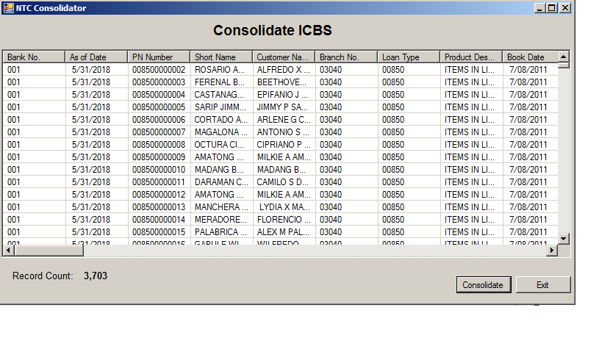
  - Figure 1.2 Click “Generate” button and Display Confirmation Message
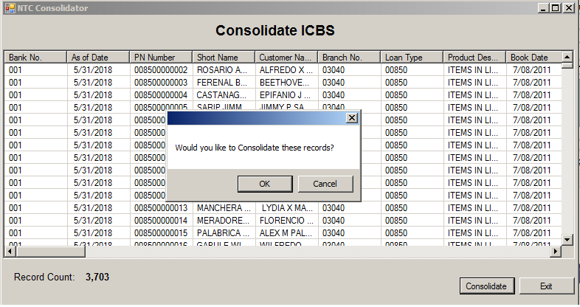
  - Figure 1.3 Display Message “Process Completed”
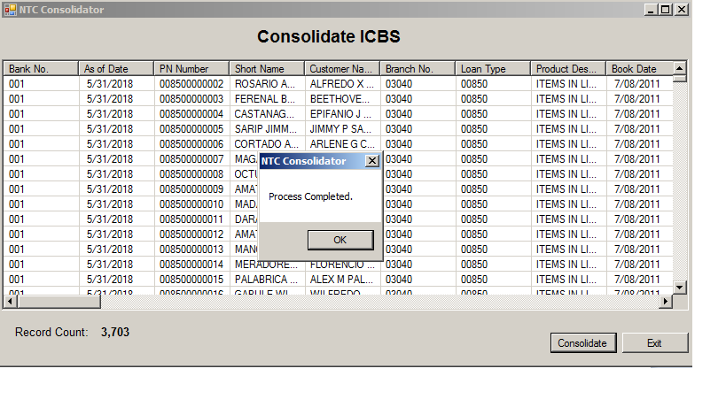
  - Figure 2.0 Consolidate AAF

  - Figure 2.1 Display records to process
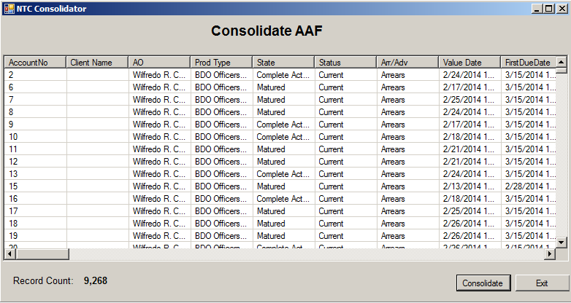
  - Figure 2.2 Click “Generate” button and Display Confirmation Message
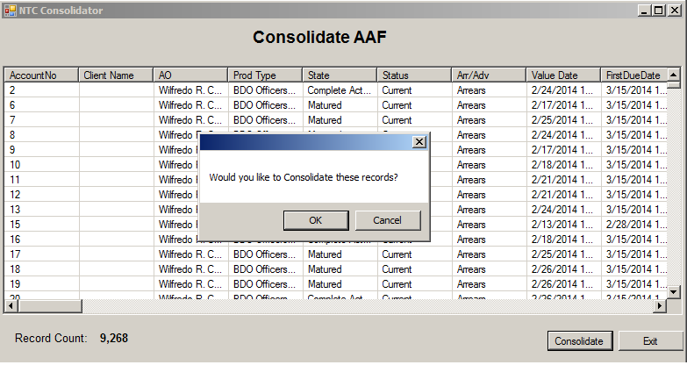

  - Figure 2.3 Display Message “Process Completed”
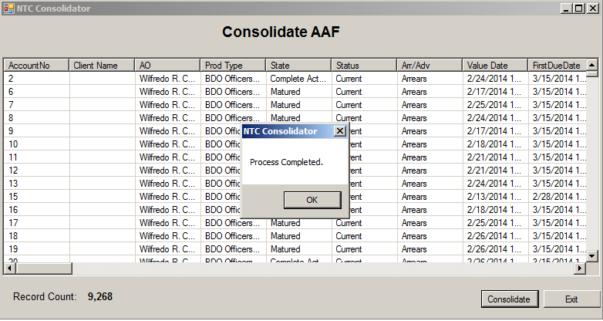
  - Figure 3.0 Consolidate FaMS

  - Figure 3.1 Display records to process
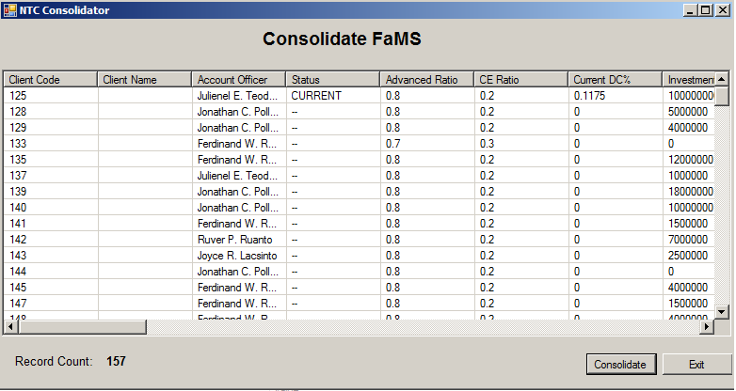
  - Figure 3.2 Click “Generate” button and Display Confirmation Message
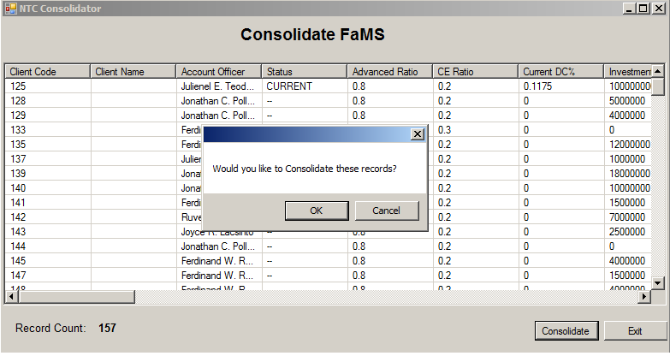

  - Figure 3.3 Display Message “Process Completed”

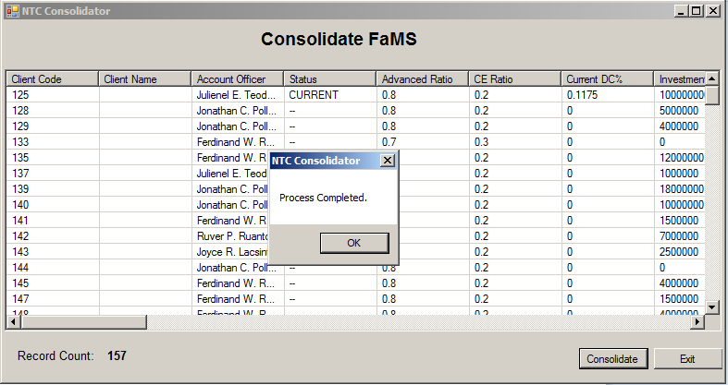

  - Figure 8.0 Process Daily GL File

  - Figure 8.1 Display records to process
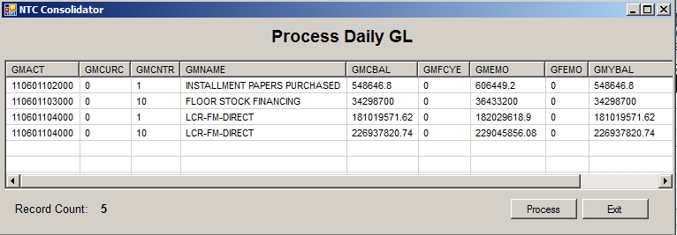

  - Figure 8.2 Click “Process” button and Display Confirmation Message
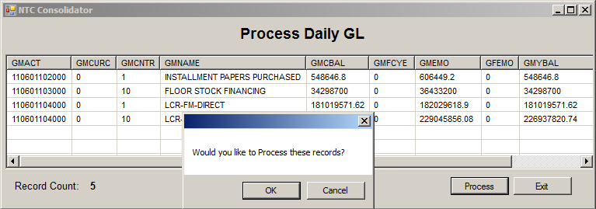
  - Figure 8.3 Display Message “Process Completed”
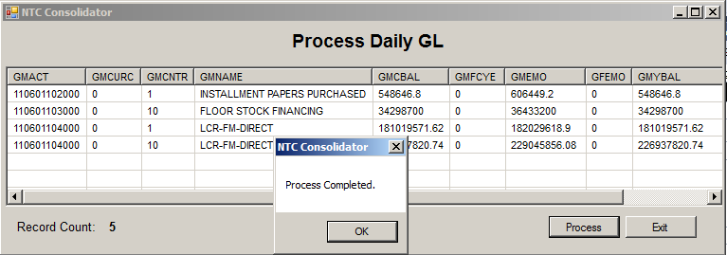
  - Figure 9.0 Consolidated NTC Report

  - Figure 9.1 Enter Parameter
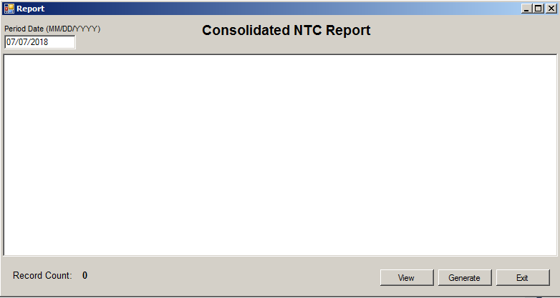

  - Figure 9.2 Click “View” button and display records
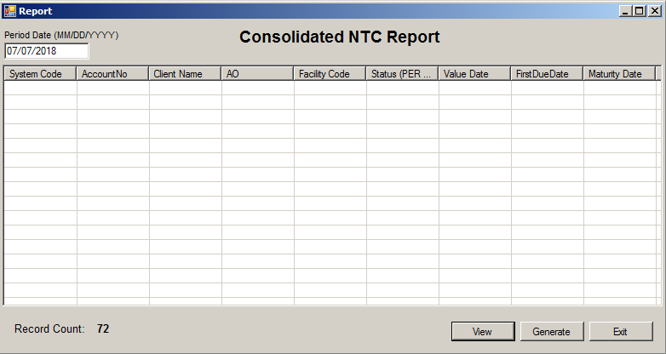
  - Figure 9.3 Click “Generate” button and Display Confirmation Message
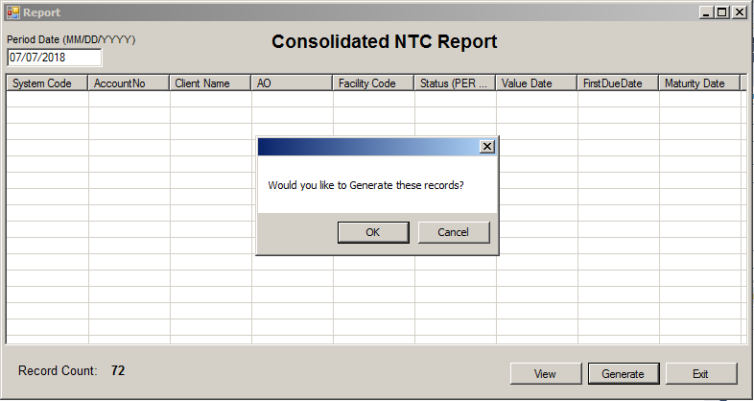
  - Figure 9.4 Display Message “Generation Completed”
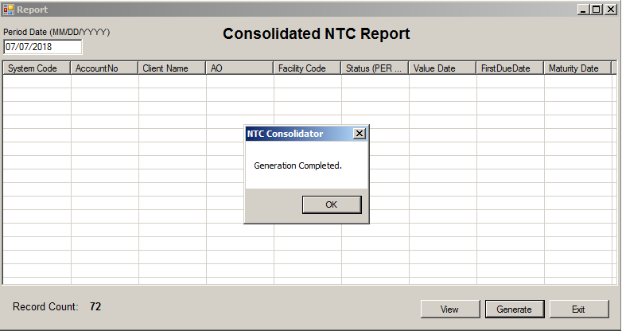

  - Figure 10.0 Consolidated NTC Report Summary

  - Figure 10.1 Enter Parameter
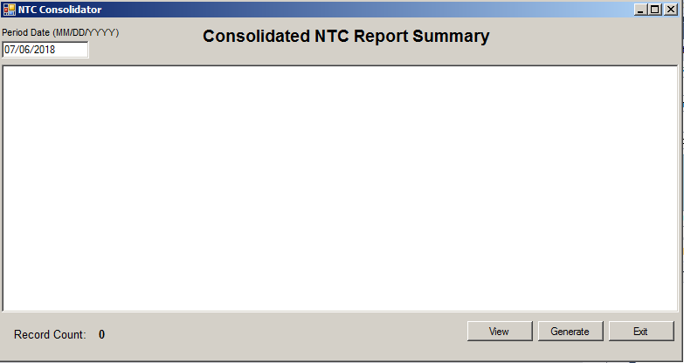
  - Figure 10.2 Click “View” button and display records
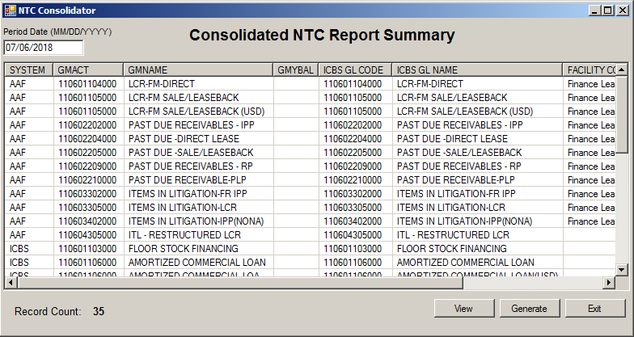

  - Figure 10.3 Click “Generate” button and Display Confirmation Message
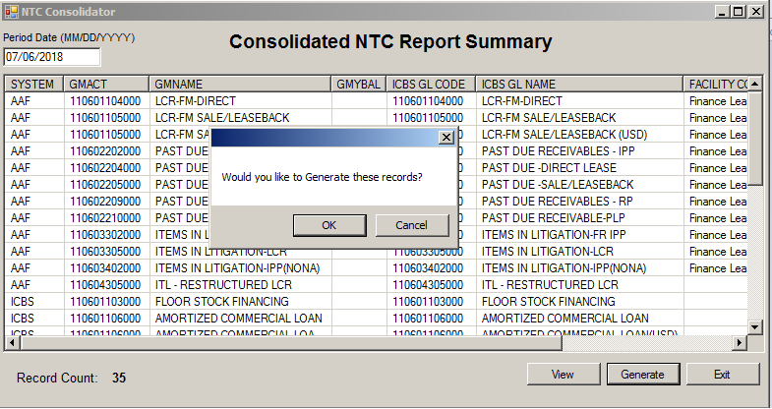
  - Figure 10.4 Display Message “Generation Completed”
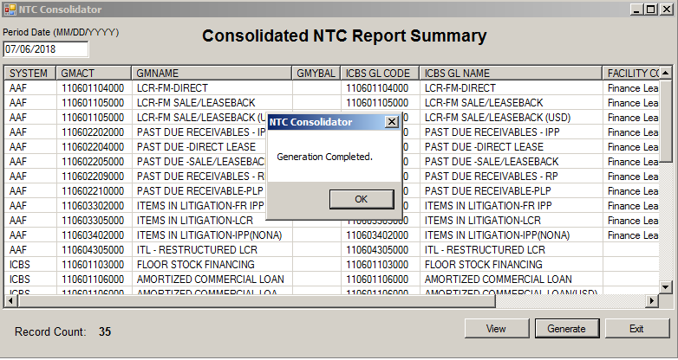
  - Figure 11.0 ICBS Blank Industry Code Report

  - Figure 11.1 Enter Parameter
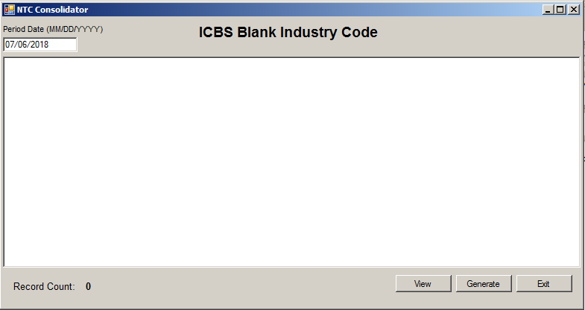
  - Figure 11.2 Click “View” button and display records
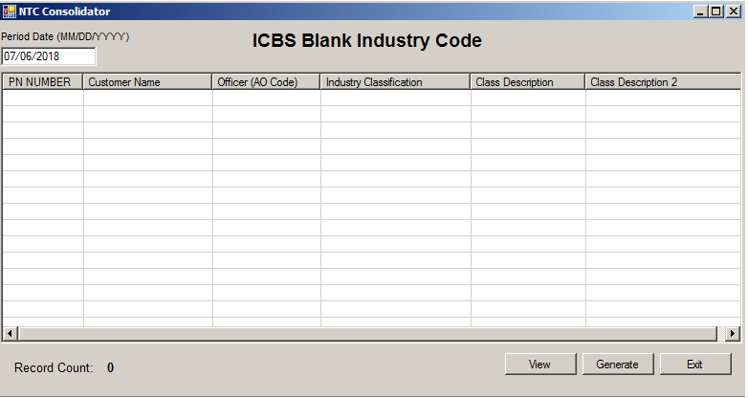
  - Figure 11.3 Click “Generate” button and Display Confirmation Message
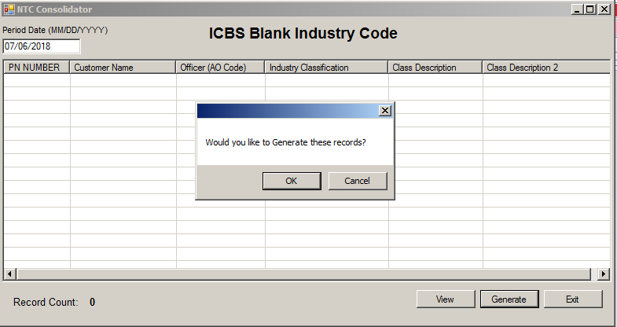

  - Figure 11.4 Display Message “Generation Completed”
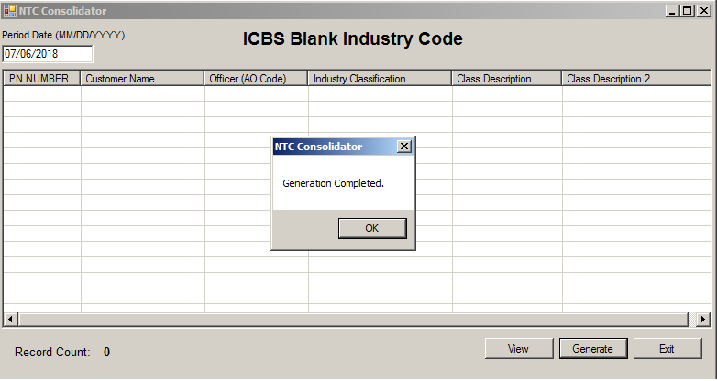
  - Figure 12.0 ICBS Zero Asset Size Report

  - Figure 12.1 Enter Parameter
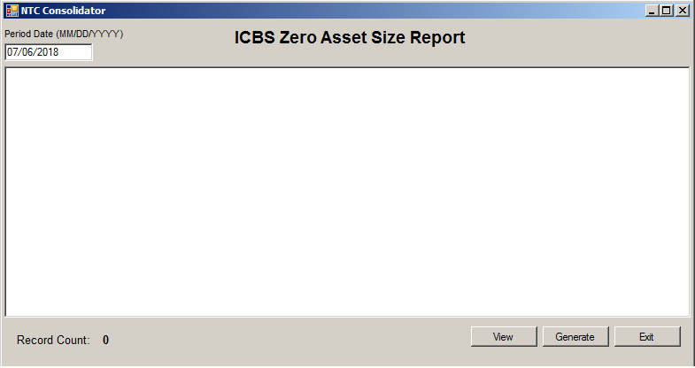
  - Figure 12.2 Click “View” button and display records
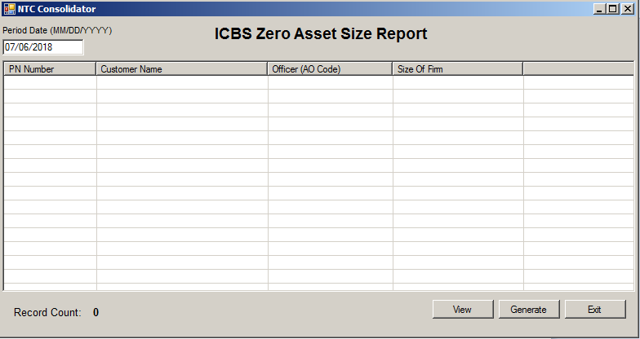

  - Figure 12.3 Click “Generate” button and Display Confirmation Message
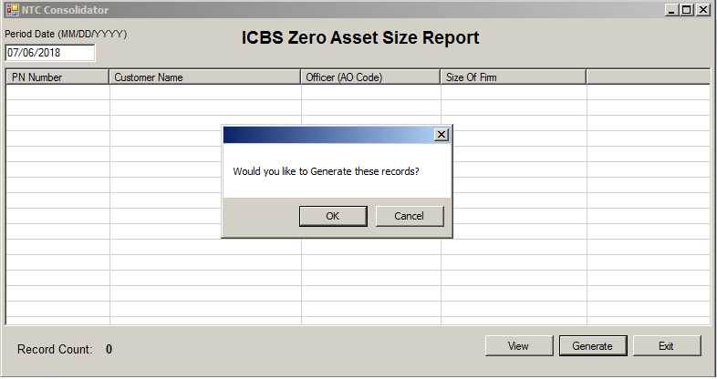
  - Figure 12.4 Display Message “Generation Completed”
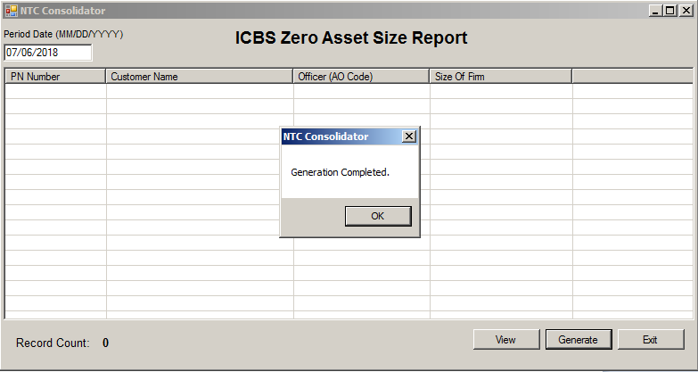

  - Figure 13.0 ICBS DOSRI Tagging Report

  - Figure 13.1 Enter Parameter
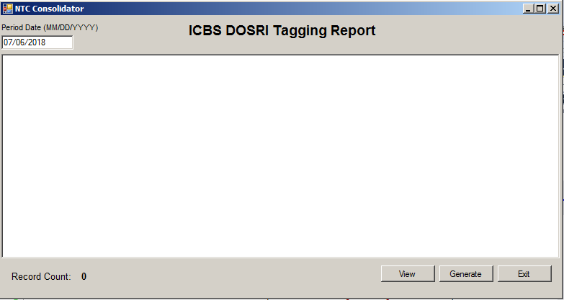

  - Figure 13.2 Click “View” button and display records
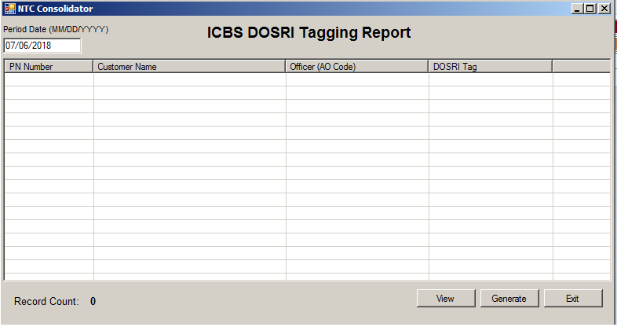
  - Figure 13.3 Click “Generate” button and Display Confirmation Message
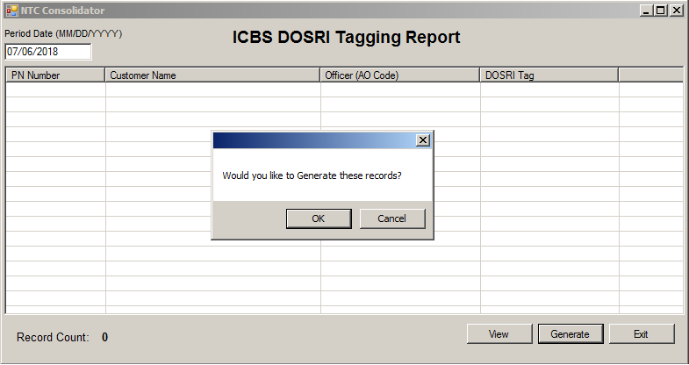
  - Figure 13.4 Display Message “Generation Completed”
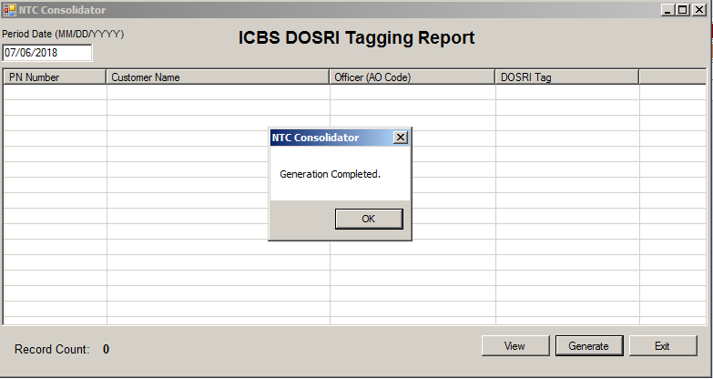

  - Figure 14.0 AAF Blank Industry Code Report

  - Figure 14.1 Enter Parameter
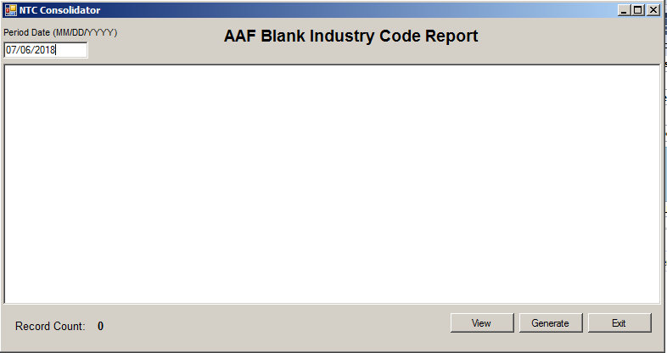
  - Figure 14.2 Click “View” button and display records
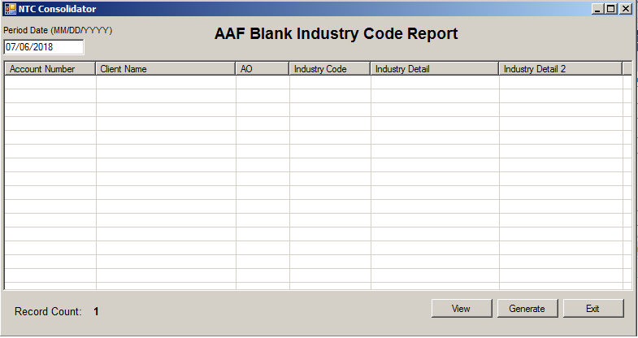
  - Figure 14.3 Click “Generate” button and Display Confirmation Message
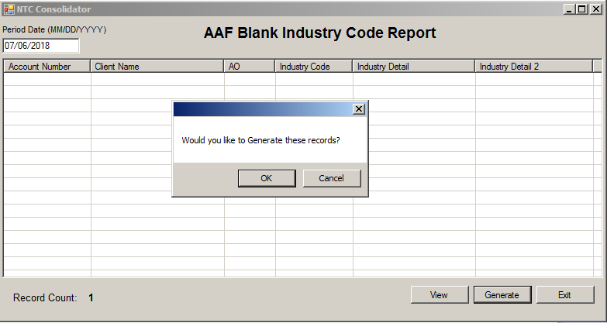

  - Figure 14.4 Display Message “Generation Completed”
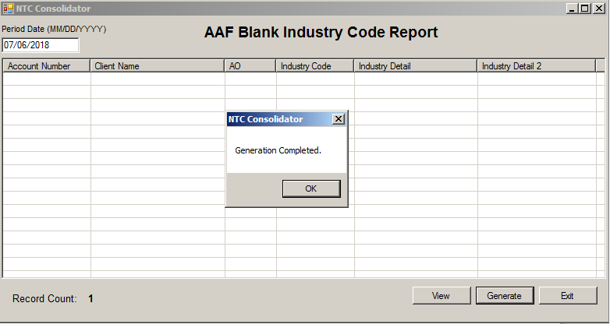
  - Figure 15.0 AAF Zero Asset Size Report

  - Figure 15.1 Enter Parameter
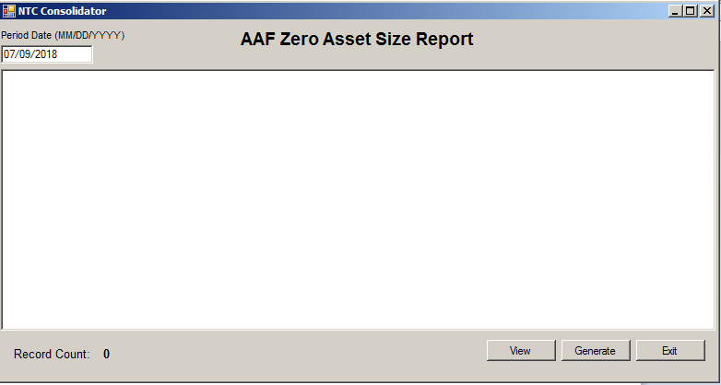

  - Figure 15.2 Click “View” button and display records
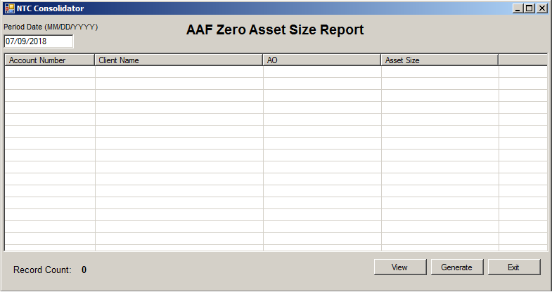
  - Figure 15.3 Click “Generate” button and Display Confirmation Message
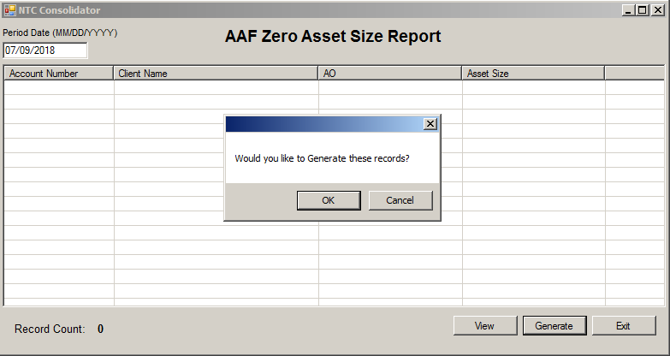
  - Figure 15.4 Display Message “Generation Completed”
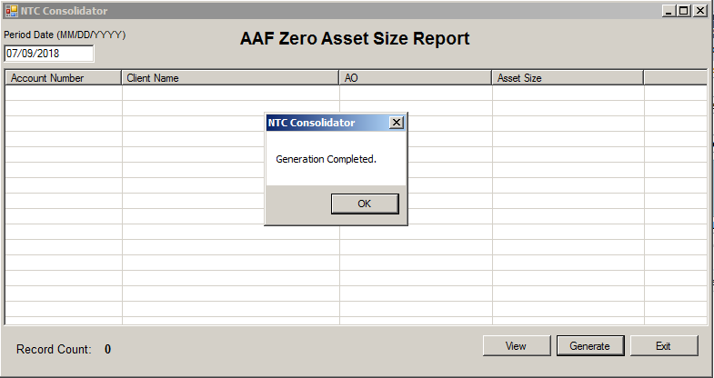

  - Figure 16.0 AAF DOSRI Tagging Report

  - Figure 16.1 Enter Parameter
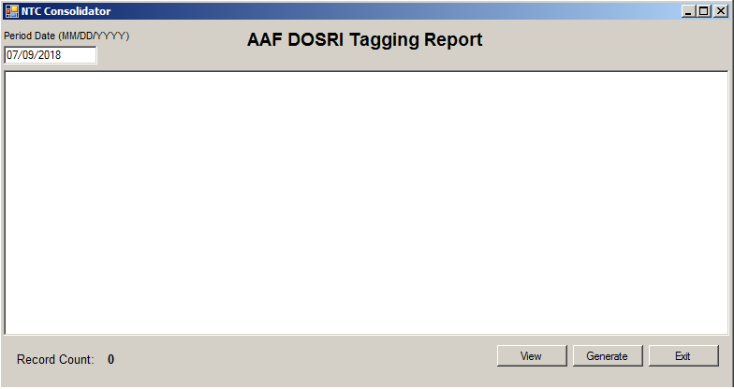
  - Figure 16.2 Click “View” button and display records
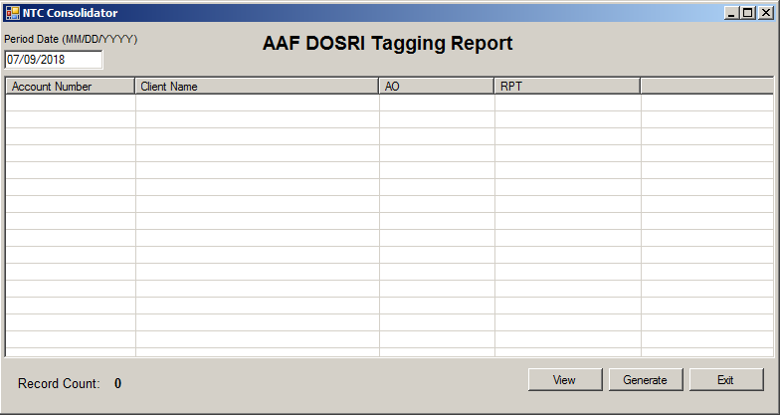
  - Figure 16.3 Click “Generate” button and Display Confirmation Message
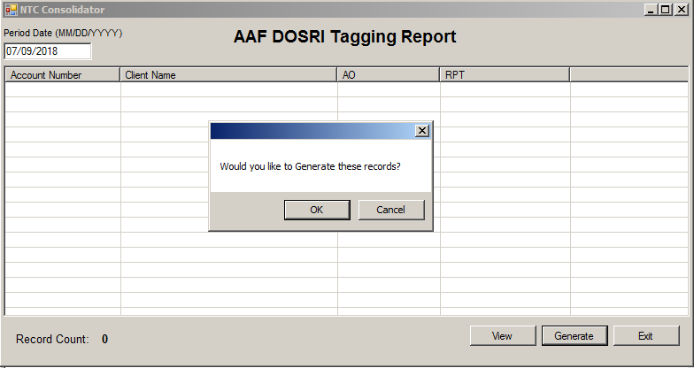

  - Figure 16.4 Display Message “Generation Completed”
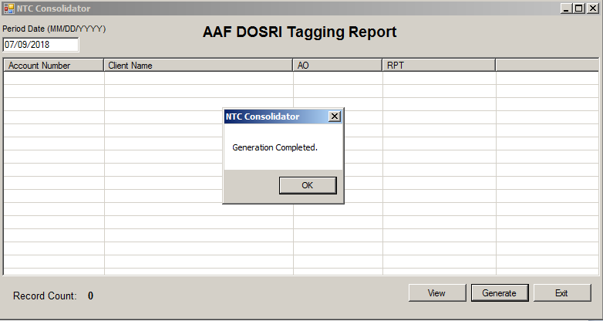
  - Figure 17.0 Difference in Tagging of Risk and GL Report

  - Figure 17.1 Enter Parameter
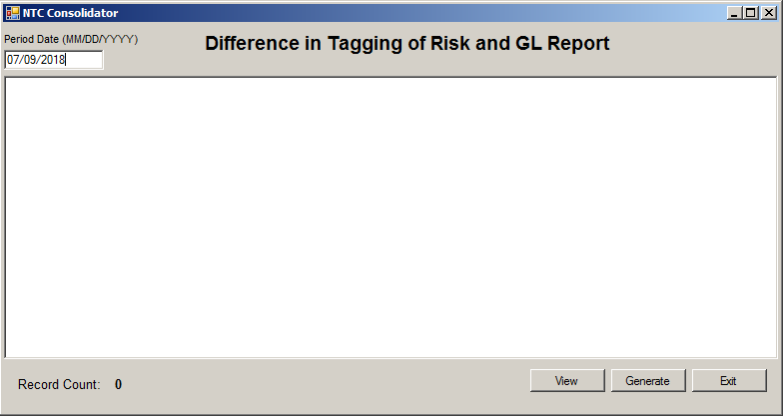

  - Figure 17.2 Click “View” button and display records
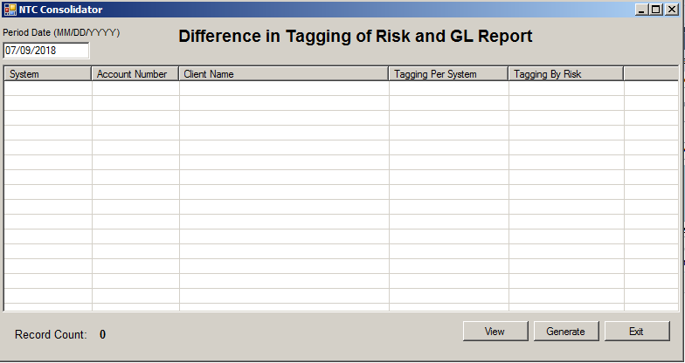
  - Figure 17.3 Click “Generate” button and Display Confirmation Message
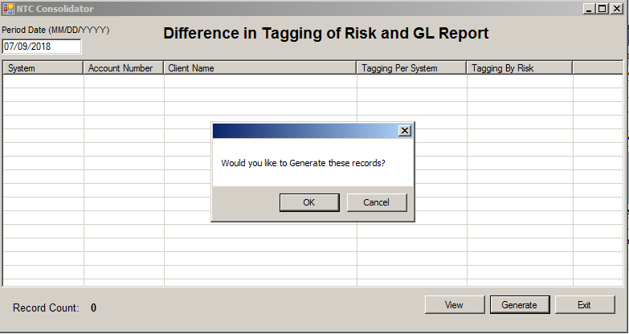
  - Figure 17.4 Display Message “Generation Completed”
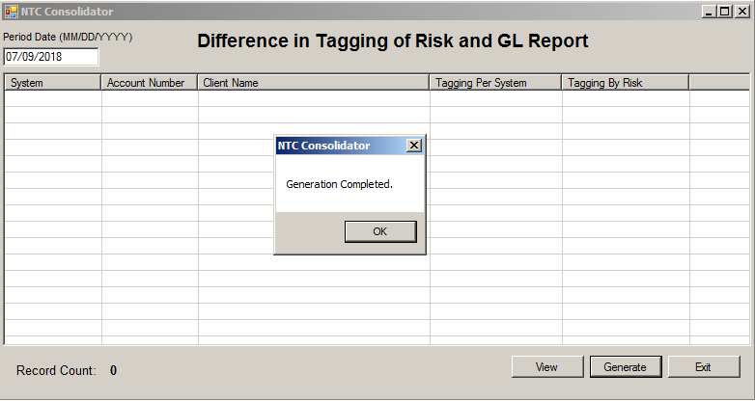

  - Figure 18.0 Consolidated AAF, ICBS and FaMS Report

  - Figure 18.1 Enter Parameter
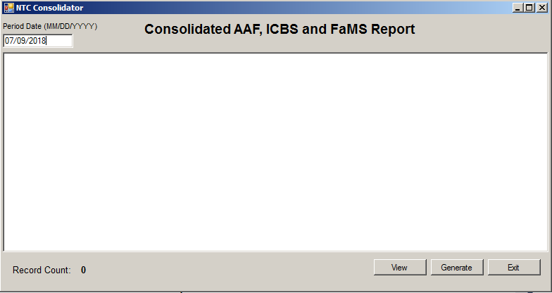
  - Figure 18.2 Click “View” button and display records
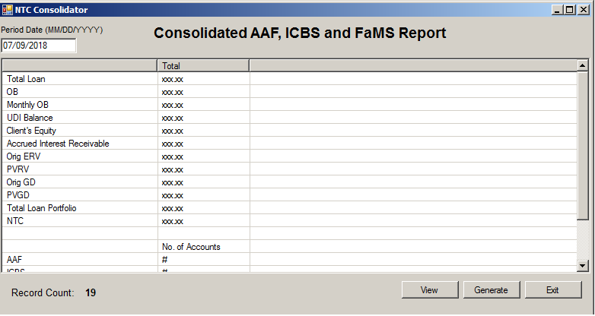
  - Figure 18.3 Click “Generate” button and Display Confirmation Message
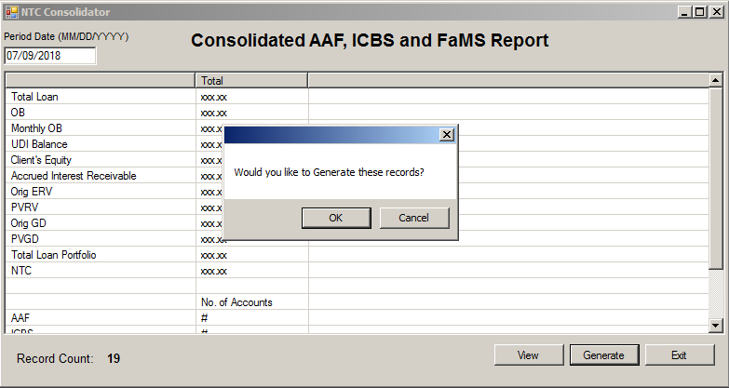

  - Figure 18.4 Display Message “Generation Completed”
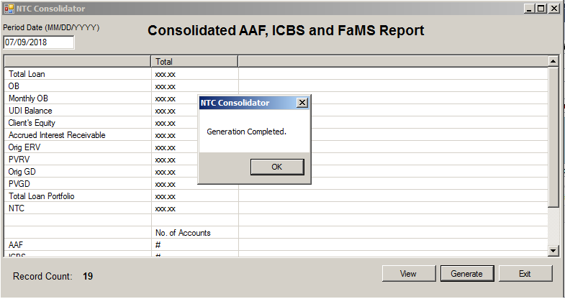
  - Figure 19.0 Maintenance Qualifying Table

  - Figure 19.1 Display Maintenance Qualifying Table Data Entry Form

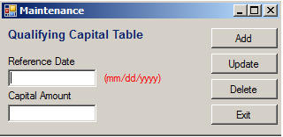
  - Figure 19.2 Input Reference Date and Amount. Click “Add” button and Display Message “Record Added”

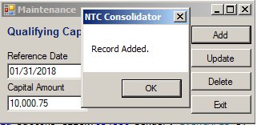

  - Figure 19.3 Input Reference Date and Amount. Click “Update” button and Display Message “Record Updated”

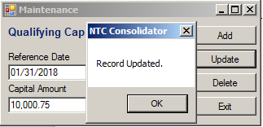

  - Figure 19.4 Input Reference Date and Amount. Click “Delete” button and Display Message “Record Deleted”
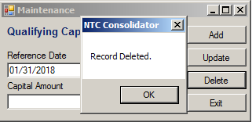
  - Figure 20.0 Maintenance US Dollar Exchange Rate

  - Figure 20.1 Display Maintenance US Dollar Exchange Rate Data Entry Form

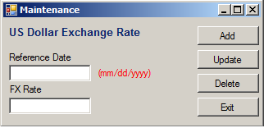

  - Figure 20.2 Input Reference Date and FX Rate. Click “Add” button and Display Message “Record Added”

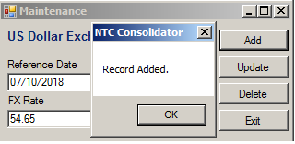

  - Figure 20.3 Input Reference Date and FX Rate. Click “Update” button and Display Message “Record Updated”

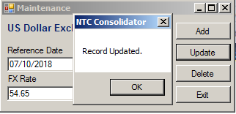

  - Figure 20.4 Input Reference Date and FX Rate. Click “Delete” button and Display Message “Record Deleted”

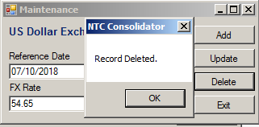

  - Figure 21.0 Maintenance GL Code and Description

  - Figure 21.1 Display Maintenance GL Code and Description Data Entry Form

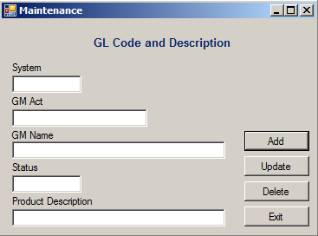

  - Figure 21.2 Input System, GM Act., GM Name, Status and Product Description. Click “Add” button and Display Message “Record Added”

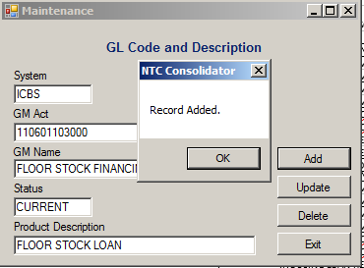

  - Figure 21.3 Input System, GM Act., GM Name, Status and Product Description. Click “Update” button and Display Message “Record Updated”

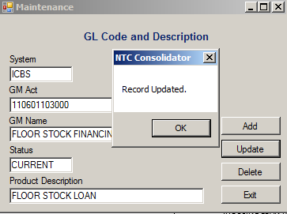

  - Figure 21.4 Input System and GM Act. Click “Delete” button and Display Message “Record Deleted”

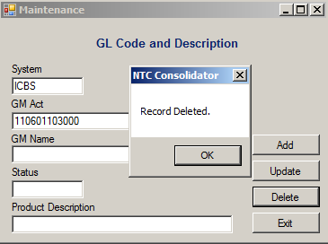

- Data Flow

ICBS NTC File

Upload and Append

NTC
Consolidator

Pull and Append
Pull and Append
AAF Database
FaMS Database

Accounts under Litigation
Qualifying Table
Maintenance
AAF Migrated Accounts
NTC Consolidator Database
Adjustment / Correction
US Dollar Exchange Rate
Update
APL from Risk
GL Code and Description
Append
Generate Excel
File
Daily GL
FaMS Past due Accounts

ICBS – Zero Asset
Size
ICBS – Blank
Industry Code
AAF – Blank
Industry Code
ICBS – DOSRI
Tagging
Consolidated NTC
Report Summary
Consolidated NTC
Report

AAF – DOSRI
Tagging
AAF – Zero Asset
Size
Difference in
Tagging of Risk and
GL
Consolidated AAF,
ICBS and FaMS
Report

- Performance Levels
  - Response time for ICBS, AAF and FaMS Consolidation process is approximately at most 2 minute while generation of report into excel file is approximately 30 seconds each.

- Security Features
  - Not Applicable

- User Roles
  - Accounting MIS will provide Text file from ICBS.
  - Accounting MIS will provide Excel files of Accounts under Litigation, Migrated Accounts, FaMS Past due Accounts, APL from Risk and Daily GL File.
  - Execution of Consolidation Process will be done by Accounting MIS.
  - Generation of All Report in Excel will be done by Accounting MIS .
  - Execution of Adjustment/Correction Process will be done by Accounting MIS.
  - Maintenance will be done by Accounting MIS.

SIGN-OFF
PREPARED BY  Maylyn B. Pedreza  Denver J. Quioyo  Benjamin J. Guerrero II  Honorato M. Gonzales  Signature over Printed Name  DATE | BUSINESS UNIT REPRESENTATIVE  Ryan R. Dedoblado / Romell A. Gamboa  Joann C. Casin / Albert D. Estrella  Desiree M. Guerrero / Vivian D. Miranda  Frederick R. Labog  Signature over Printed Name  DATE
ITD UNIT HEAD  Jonas J. Salonga  Signature over Printed Name  DATE | BUSINESS UNIT HEAD  Agerico S. Verzola  Juanito C. Lucas  Cecilia L. Naranjo  Peter Blair S. Agustin  Signature over Printed Name  DATE

